

Marketing data analysis

Mojtaba Peyrovi(Moji)

## Data Analysis & Presentation Task:

First, let’s explore the data and answer the first question any company is interested to know:

**“ Are we doing good with our social media marketing? “**

Well, in order to answer this question, I made a table showing Reach & Spend per day. Let’s divide Reach by Spend. It shows how much Reach each 1 USD has brought to the Facebook page. Let’s visualize it:

Unfortunately, I should inform my client (although they may don’t like to hear it,) they are not doing good and the performance is being decreased.

Why Reach and not Impressions?

* Because the impressions are not unique. A user can have multiple impressions to one post, while Reach is unique for each visitor.

What question I would have to ask the client?

* I need to know how much of the traffic is Paid and how much is Organic. It would be a great indicator of how well a company is doing. In this analyze I assumed all the traffic is Paid.
* I wish I knew the following variables:
  + Instagram daily clicks. Based on the clicks I could calculate Cost Per Click(CPC) and Click-Through Rate(CTR) for Instagram, which are important metrics.
  + The percentage of daily spending on Instagram compared to Facebook so that I could have a better judgement on Instagram performance.
* I need to know how much revenue each campaign has brought to the company and how much the conversion rates have been.
* Likes of each post can be extracted from FB API and we can use it to calculate Cost per Like(CPL.)

Which campaign is performing the best?

* For answering this question, I made a following table (the original excel file will be sent to the examiner by email). This table shows the performance of each campaign for each month and total, also it is separated by Facebook and Instagram performance and total.

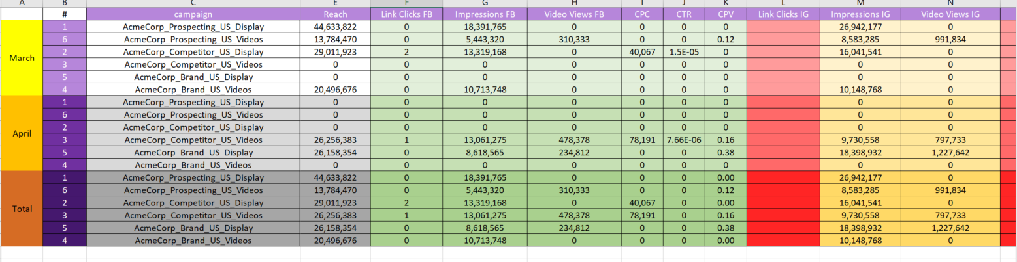because of the lack of information on IG, I decided to take the Reach and the whole Impression (FB + IG) as a performance metric. Based on these two metrics we can calculate two variables:

* Cost Per Mille (CPM): cost per 1,000 impressions which can be calculated by dividing Spend by Impressions times 1,000.
* Cost of acquiring 1,000 Reaches. Spend divided by Reach times 1,000.

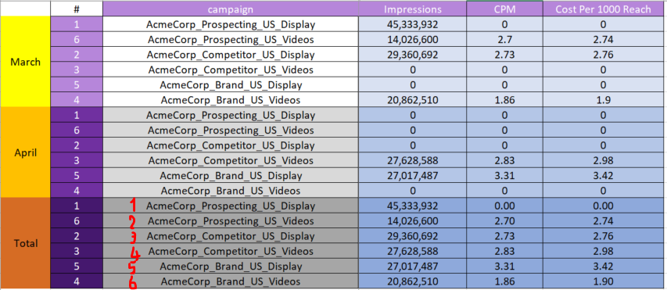According to this analysis, here is the brief for each campaign:

* Campaign 1: we haven’t spent anything on this campaign and it has made a big influence, all organic. So, of course this campaign is the best.
* Campaign 4,5: These two campaigns have been so expensive.
* Campaign 6: This campaign is the second cheap one.
* Campaign 2,3: these campaigns are second expensive ones.

Although some of the campaigns have been expensive, if they can make revenue for the company and have high conversion rate, they can be acceptable. Because the revenue information hasn’t been provided, we just have to judge on how much Impressions/Reach they have been able to make.

Which additional metrics we can provide?

* Facebook CPC
* Facebook CTR
* Facebook Cost Per Video (CPV)
* Instagram CPV
* CPM
* Cost Per 1,000 Reach

In the main excel file that would be sent by email, I have made the daily summary for each campaign in different sheets.

Budget Adjusting Idea?

I have made an analysis called “budget” in the source file. First calculated daily average spending. Then we have campaigns with their CPM and cost per 1,000 reach being calculated already. Moreover, we can calculate daily spending on each campaign.

Obviously, we need to re-adjust the spending policy. I defined 6 scenarios.

* Scenario 1: Even allocation. We have 6 assignment and daily budget of 5321 USD. Let’s give each campaign 887 USD.
* Scenario 2: Allocating 50% of budget to the best campaign and dividing the rest of the budget to the five remaining campaigns based on their Reach coefficient. (the coefficient shows how much of the total Reach has been made by a specific campaign in percentage.)
* Scenario 3: Similar to scenario two but allocating 30% to the top campaign.
* Scenario 4: Similar to Scenario two but allocating 80% to the top campaign.
* Scenario 5: Allocating 30% to the top campaign, decreasing from others and adding up to the first campaign.
* Scenario 6: Allocating 30% to the top campaign, decreasing from others and adding up to the second campaign.

Here is the brief results of each scenario:

|  |  |  |  |
| --- | --- | --- | --- |
| scenario | | Reach | Impressions |
| Current plan | 160,341,628 | | | 164,229,809 |
| Scenario 1 | 146,383,696 | | | 149,680,294 |
| Scenario 2 | 124,222,270 | | | 159,679,913 |
| Scenario 3 | 162,375,770 | | | 164,049,563 |
| Scenario 4 | 145,968,530 | | | 149,265,128 |
| Scenario 5 | 169,512,391 | | | 171,761,414 |
| Scenario 6 | 183,030,296 | | | 184,704,089 |

Scenario 6 can increase Reach and Impressions rate.

Performance trends?

For answering this question I used Pandas and Seaborn libraries in Python to visualize the data to see if there is any trend.

First, imported the sheet named “daily”. In this sheet we have the “performance” value which is showing how much Reach each 1 USD spent has been obtained.

* Let’s see if there is any meaningful correlation between weekdays and performance. A pivot table from this data shows the performance per weekday for each month. Let’s see the heatmap:

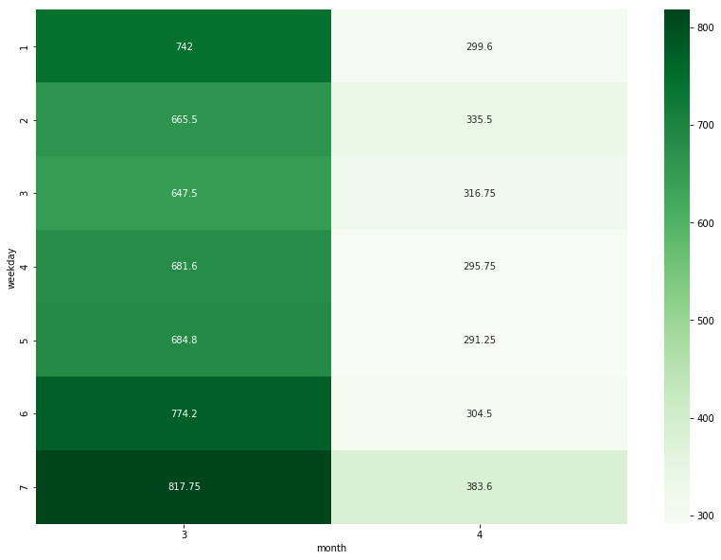

As we can see on weekdays 6,7 (Saturday & Sunday) we are doing better. Also, in the first month, day 1 (Monday) has been doing good(it can be due to a viral post).

* Now, we can check if each of the four weeks of a month have different performance or not. Again, I made a new pivot table and a heatmap based on that to check the trend.

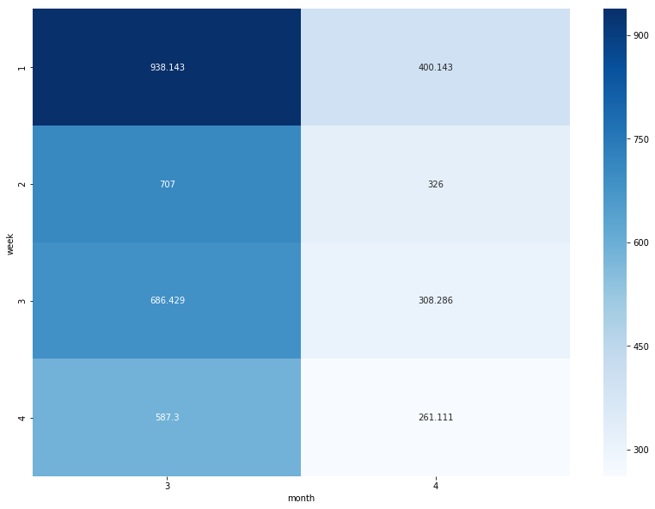

Interestingly, we can see the weekly performance of each month decreases subsequently (both within the month and totally.)

**This information should be considered when we want to allocate daily marketing budgets.**

## TAGGING PROPOSAL

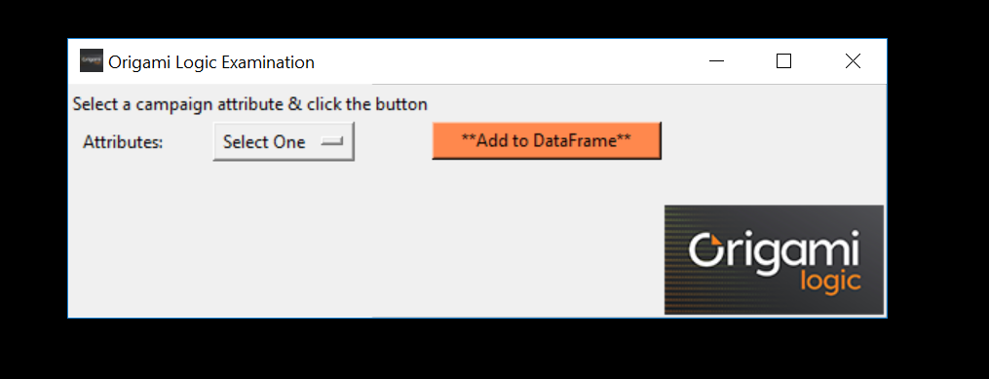For this assignment I made a basic interface using Python Tkinter,Pandas, and Pillow libraries. Let’s go through it briefly.

As we know each campaign name contains the following attributes:

{CompanyName}_{CampaignType}_{Country}_{AdType}

Using this app we can choose any of the four attributes from a dropdown and the associated column will be added to the main dataset.

The source code will be sent to the examiner by email.

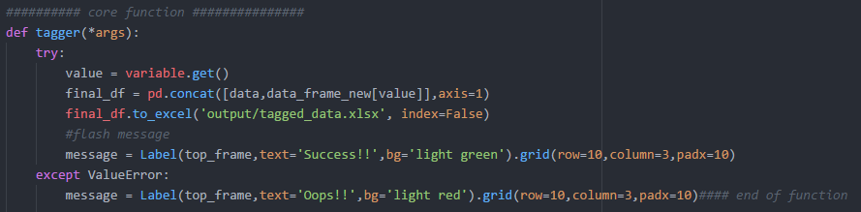 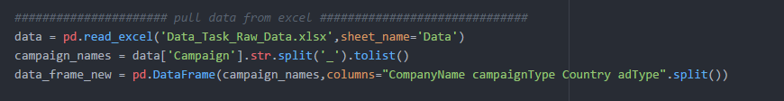Here I’m explaining how the core function works:

**First part:**

The file gets be pulled by Pandas to Python.

The data within “Campaign” column separated by “_” get and saved in new lists.

Then Pandas makes a new data frame using the list of new attributes each one as a column.

**Second part:**

Concatenates the associated column to the selected attribute with the main data file.

The new dataset named “tagged_data.xlsx” gets generated and copied in “output” folder. We can use RegEx techniques to define dynamic file names, but for now I just hardcoded the name.

Finally, If the function works properly, the application prints a success message, otherwise there will be an error message.

The rest of the code is associated with the UI design.